- Screenshots of the program output
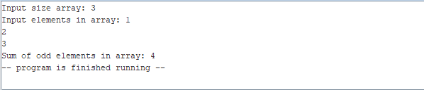
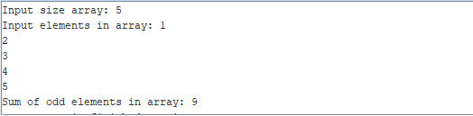

- What percentage of the work is done?
- 96.69%, I guess.

